**ASSIGNMENT-1**

**By**

***Student Name-ROHIT KUMAR***

**Roll Number-2023A7R021**

**Semester-FIRST**

**Department Name-CSE(CYBER SECURITY)**



**Model Institute of Engineering & Technology (Autonomous)**

(Permanently Affiliated to the University of Jammu, Accredited by NAAC with “A” Grade)

Jammu, India

2023



//WRITE A PROGRAM TO SELECT THE BEST PRODUCT FROM THE OFFER.

#include <stdio.h>

void selectProducts(int n,float discounts[],float minDiscount,float maxDiscount)

{

    printf("Selected Products:\n");

    for(int i=0;i<n;i++)

    {

        if(discounts[i]>=minDiscount&&discounts[i]<=maxDiscount)

        {

            printf("Product%d:%.2f%%discount\n",i+1,discounts[i]);

        }

    }

}

int main()

{

    int n;

    printf("Enter the number of products:");

    scanf("%d",&n);

    if(n<=0)

    {

        printf("Invalid input. Number of products should be greater than 0.\n");

        return 1;

    }

    float discounts[n];

    printf("Enter the discounts for each product:\n");

    for (int i=0;i<n;i++)

    {

        printf("Product%d:",i+1);

        scanf("%f",&discounts[i]);

    }

    float minDiscount,maxDiscount;

    printf("Enter Mr. Ravi's specified discount range (min max):");

    scanf("%f%f",&minDiscount,&maxDiscount);

    if (minDiscount<0||maxDiscount>100||minDiscount>maxDiscount)

    {

        printf("Invalid input.Please enter valid discount range(0to100) and min <=max.\n");

        return 1;

    }

    selectProducts(n,discounts,minDiscount,maxDiscount);

    return 0;

}

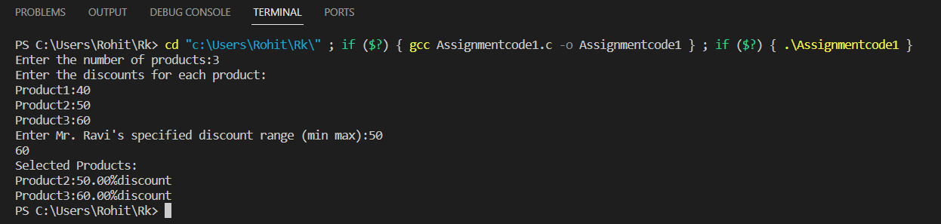

//WRITE A C PROGRAM TO CHECK IF A STRING IS A PALINDROME.

#include<stdio.h>

void main()

{

    char a[100];

    printf("Enter the string:");

    scanf("%[^\n]s",a);

    int i,len=0;

    for(i=0;;i++)

    {

        if(a[i]=='\0')

        break;

        else

        len++;

    }

    printf("Length of the string is=%d",len);

    char b[len];

    int j=0;

    for(i=len-1;i>=0;i--)

    {

        b[j]=a[i];

        j++;

    }

    printf("The reversed string%s",b);

    int flag=0;

    for(i=0;i<len;i++)

    {

        int m=a[i];

        int n=b[i];

        if(m!=n)

        {

            flag=1;

            break;

        }

    }

    if(flag==0)

    printf("The given string is pallindrome");

    else

    printf("The given string is not pallindrome");

}

